**OPIM 3221 Name: Daniel Lesh**

**Assignment #3 - Queries and Views**

**Problem 1 -**

**Using the following three tables create a final view to answer the given query. Make sure the four steps of the process are following for full credit (Step 1 - combine, Step 2 - copy and reject, Step 3 - remove redundant fields, Step 4 – Answer the Query. Only use the space you need in the blank tables to create your views.)**

Grading Rubric: **(Total points)**

* 1 point for correctly combining each record in Step 1
  + 1 point for correctly combining each field in Step 1
* 1 point for correctly rejecting each record in Step 2
* 1 point for correctly listing the non-rejected records in Step 3
  + 1 point for correctly removing redundant fields in Step 3
* 3 points for answering the query correctly in Step 4

**Query: Give me the Fund Name and Email Address for the customer who donated $50.00**

|  |  |  |  |
| --- | --- | --- | --- |
| **FundID** | **Fund_Name** | **Event_Date** | **Type** |
| F15 | Casino Night | 05/11/2006 | Office |
| F23 | Fun Run | 09/27/2007 | Charity |
| F01 | Party Planning | 12/14/2006 | Office |

**Table A**

|  |  |  |
| --- | --- | --- |
| **Donor_ID** | **Customer_Name** | **Email_Address** |
| D20 | Jim Halpert | james.halpert@gmail.com |
| D12 | Pam Beesly | pamela.beesly@gmail.com |
| C15 | Dwight Schrute | dwight.schrute@hotmail.com |

**Table B**

|  |  |  |
| --- | --- | --- |
| **FundID** | **Donor_ID** | **Amount_Donated** |
| F01 | D12 | $50.00 |
| F23 | D20 | $25.00 |

**Table C**

**Step1: Combined View (16 + 10)**

|  |  |  |  |  |  |  |  |  |  |
| --- | --- | --- | --- | --- | --- | --- | --- | --- | --- |
| **FundID** | **Fund_Name** | **Event_Date** | **Type** | **Donor_ID** | **Customer_Name** | **Email_Address** | **FundID** | **Donor_ID** | **Amount_Donated** |
| F15 | Casino Night | 05/11/2006 | Office | D20 | Jim Halpert | james.halpert@gmail.com | F01 | D12 | $50.00 |
| F15 | Casino Night | 05/11/2006 | Office | D20 | Jim Halpert | james.halpert@gmail.com | F23 | D20 | $25.00 |
| F15 | Casino Night | 05/11/2006 | Office | D12 | Pam Beesly | pamela.beesly@gmail.com | F01 | D12 | $50.00 |
| F15 | Casino Night | 05/11/2006 | Office | D12 | Pam Beesly | pamela.beesly@gmail.com | F23 | D20 | $25.00 |
| F15 | Casino Night | 05/11/2006 | Office | C15 | Dwight Schrute | dwight.schrute@hotmail.com | F01 | D12 | $50.00 |
| F15 | Casino Night | 05/11/2006 | Office | C15 | Dwight Schrute | dwight.schrute@hotmail.com | F23 | D20 | $25.00 |
| F23 | Fun Run | 09/27/2007 | Charity | D20 | Jim Halpert | james.halpert@gmail.com | F01 | D12 | $50.00 |
| F23 | Fun Run | 09/27/2007 | Charity | D20 | Jim Halpert | james.halpert@gmail.com | F23 | D20 | $25.00 |
| F23 | Fun Run | 09/27/2007 | Charity | D12 | Pam Beesly | pamela.beesly@gmail.com | F01 | D12 | $50.00 |
| F23 | Fun Run | 09/27/2007 | Charity | D12 | Pam Beesly | pamela.beesly@gmail.com | F23 | D20 | $25.00 |
| F23 | Fun Run | 09/27/2007 | Charity | C15 | Dwight Schrute | dwight.schrute@hotmail.com | F01 | D12 | $50.00 |
| F23 | Fun Run | 09/27/2007 | Charity | C15 | Dwight Schrute | dwight.schrute@hotmail.com | F23 | D20 | $25.00 |
| F01 | Party Planning | 12/14/2006 | Office | D20 | Jim Halpert | james.halpert@gmail.com | F01 | D12 | $50.00 |
| F01 | Party Planning | 12/14/2006 | Office | D20 | Jim Halpert | james.halpert@gmail.com | F23 | D20 | $25.00 |
| F01 | Party Planning | 12/14/2006 | Office | D12 | Pam Beesly | pamela.beesly@gmail.com | F01 | D12 | $50.00 |
| F01 | Party Planning | 12/14/2006 | Office | D12 | Pam Beesly | pamela.beesly@gmail.com | F23 | D20 | $25.00 |
| F01 | Party Planning | 12/14/2006 | Office | C15 | Dwight Schrute | dwight.schrute@hotmail.com | F01 | D12 | $50.00 |
| F01 | Party Planning | 12/14/2006 | Office | C15 | Dwight Schrute | dwight.schrute@hotmail.com | F23 | D20 | $25.00 |

**Step 2: Copy and Reject incorrect records (16)**

|  |  |  |  |  |  |  |  |  |  |
| --- | --- | --- | --- | --- | --- | --- | --- | --- | --- |
| **FundID** | **Fund_Name** | **Event_Date** | **Type** | **Donor_ID** | **Customer_Name** | **Email_Address** | **FundID** | **Donor_ID** | **Amount_Donated** |
| F15 | Casino Night | 05/11/2006 | Office | D20 | Jim Halpert | james.halpert@gmail.com | F01 | D12 | $50.00 |
| F15 | Casino Night | 05/11/2006 | Office | D20 | Jim Halpert | james.halpert@gmail.com | F23 | D20 | $25.00 |
| F15 | Casino Night | 05/11/2006 | Office | D12 | Pam Beesly | pamela.beesly@gmail.com | F01 | D12 | $50.00 |
| F15 | Casino Night | 05/11/2006 | Office | D12 | Pam Beesly | pamela.beesly@gmail.com | F23 | D20 | $25.00 |
| F15 | Casino Night | 05/11/2006 | Office | C15 | Dwight Schrute | dwight.schrute@hotmail.com | F01 | D12 | $50.00 |
| F15 | Casino Night | 05/11/2006 | Office | C15 | Dwight Schrute | dwight.schrute@hotmail.com | F23 | D20 | $25.00 |
| F23 | Fun Run | 09/27/2007 | Charity | D20 | Jim Halpert | james.halpert@gmail.com | F01 | D12 | $50.00 |
| F23 | Fun Run | 09/27/2007 | Charity | D20 | Jim Halpert | james.halpert@gmail.com | F23 | D20 | $25.00 |
| F23 | Fun Run | 09/27/2007 | Charity | D12 | Pam Beesly | pamela.beesly@gmail.com | F01 | D12 | $50.00 |
| F23 | Fun Run | 09/27/2007 | Charity | D12 | Pam Beesly | pamela.beesly@gmail.com | F23 | D20 | $25.00 |
| F23 | Fun Run | 09/27/2007 | Charity | C15 | Dwight Schrute | dwight.schrute@hotmail.com | F01 | D12 | $50.00 |
| F23 | Fun Run | 09/27/2007 | Charity | C15 | Dwight Schrute | dwight.schrute@hotmail.com | F23 | D20 | $25.00 |
| F01 | Party Planning | 12/14/2006 | Office | D20 | Jim Halpert | james.halpert@gmail.com | F01 | D12 | $50.00 |
| F01 | Party Planning | 12/14/2006 | Office | D20 | Jim Halpert | james.halpert@gmail.com | F23 | D20 | $25.00 |
| F01 | Party Planning | 12/14/2006 | Office | D12 | Pam Beesly | pamela.beesly@gmail.com | F01 | D12 | $50.00 |
| F01 | Party Planning | 12/14/2006 | Office | D12 | Pam Beesly | pamela.beesly@gmail.com | F23 | D20 | $25.00 |
| F01 | Party Planning | 12/14/2006 | Office | C15 | Dwight Schrute | dwight.schrute@hotmail.com | F01 | D12 | $50.00 |
| F01 | Party Planning | 12/14/2006 | Office | C15 | Dwight Schrute | dwight.schrute@hotmail.com | F23 | D20 | $25.00 |

**Step 3: Remove redundant fields (2 + 3)**

|  |  |  |  |  |  |  |  |  |  |
| --- | --- | --- | --- | --- | --- | --- | --- | --- | --- |
| **FundID** | **Fund_Name** | **Event_Date** | **Type** | **Donor_ID** | **Customer_Name** | **Email_Address** | **FundID** | **Donor_ID** | **Amount_Donated** |
| F23 | Fun Run | 09/27/2007 | Charity | D20 | Jim Halpert | james.halpert@gmail.com | F23 | D20 | $25.00 |
| F01 | Party Planning | 12/14/2006 | Office | D12 | Pam Beesly | pamela.beesly@gmail.com | F01 | D12 | $50.00 |

**Step 4: Answer Query (3)**

**Query: Give me the Fund Name and Email Address for the customer who donated $50.00**

|  |  |
| --- | --- |
| **Fund_Name** | **Email_Address** |
| Party Planning | pamela.beesly@gmail.com |

**Problem 2 - For the following problems screenshot your code and output (View)**

Grading Rubric: **(Total 50 points)**

* 5 points for each question
  + 1 point for posting view and output correctly
  + 4 points for parts of the query (partial points awarded)

1. The HR department needs your assistance in creating some queries. Display the last name, employee id and phone number of employees who earn less than 3000.
   * 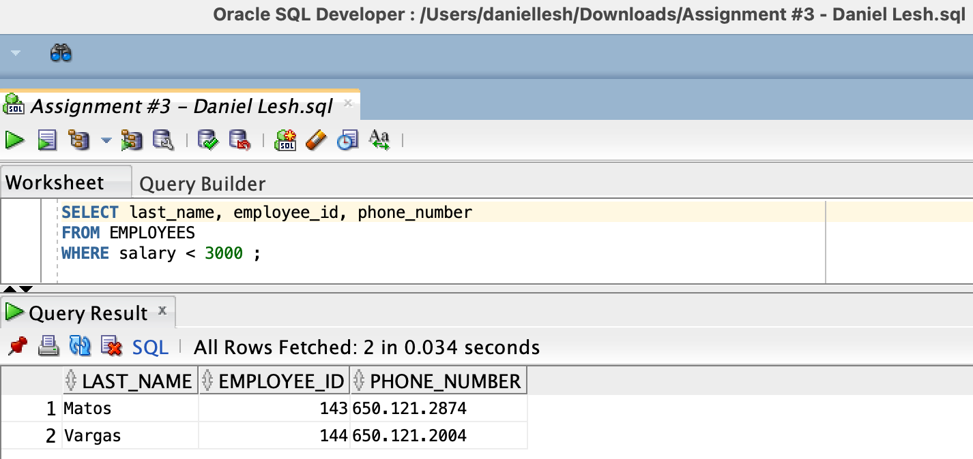
2. Open a new SQL Worksheet. Create a report that displays the last name and phone number for Employees who have a manager with manager id 100. Run the query.
   * 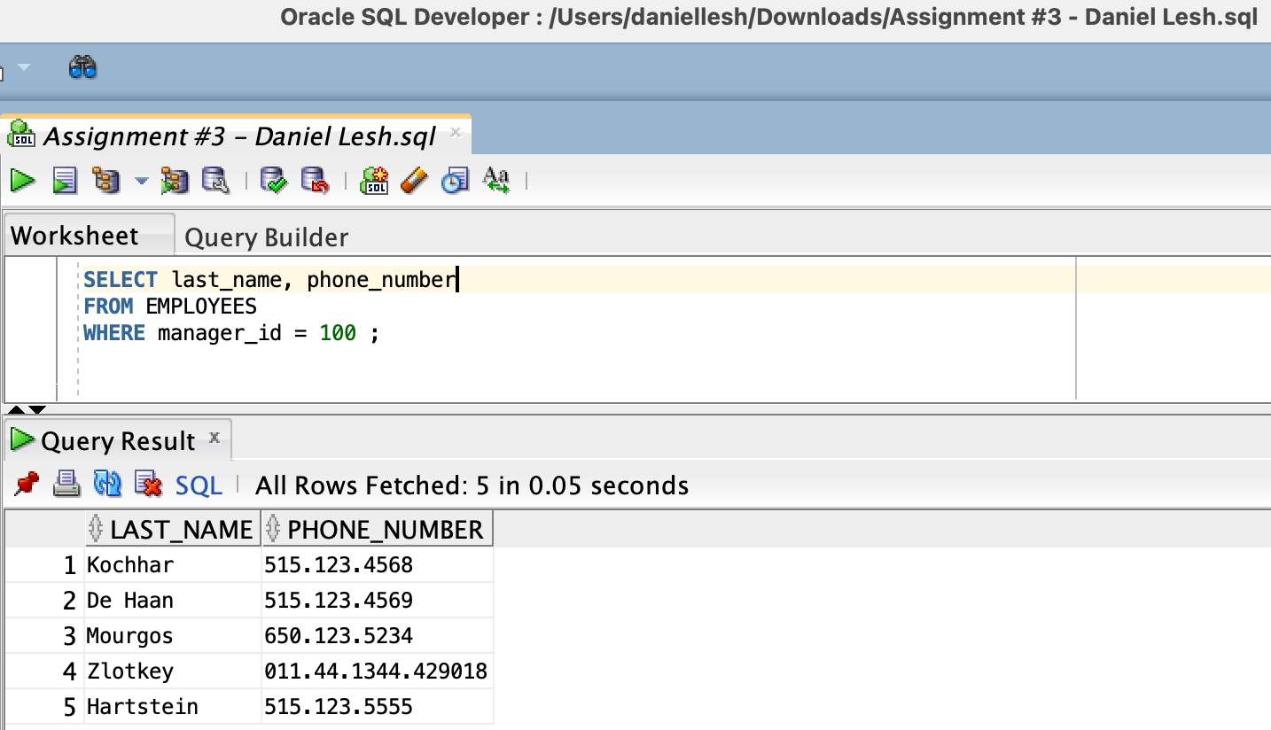
3. The HR department needs to find employees last name and salary who earn a salary between 6000 and 7000

or a salary between 8000 and 9000. Find a list of such employees in the descending order of their hire date.

* + 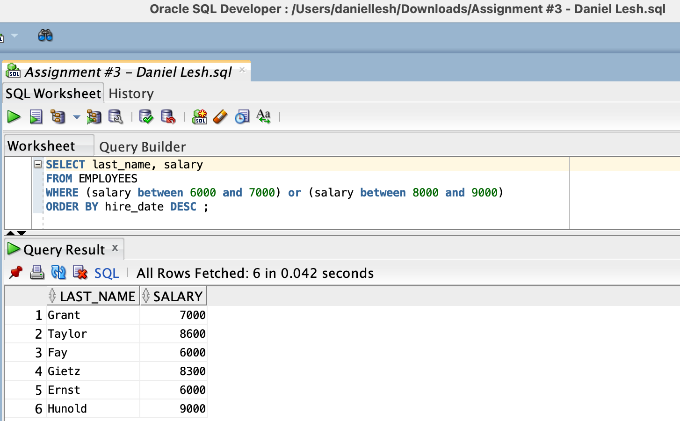

1. Create a report to display the last name, job ID, and department id for employees whose last names end

with ‘s’. Order the Query in descending order by the hire date.

* + 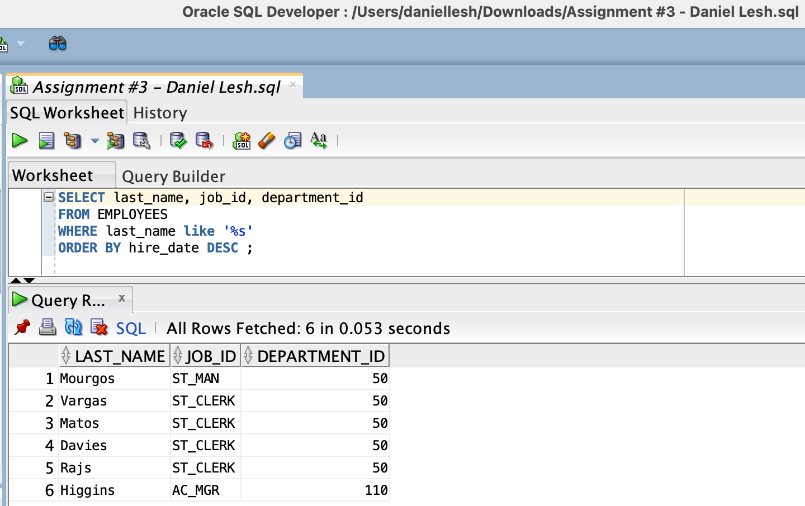

1. Display the last name, job id, and email for all employees with last name Kochhar, De Haan, or Rajs.
   * 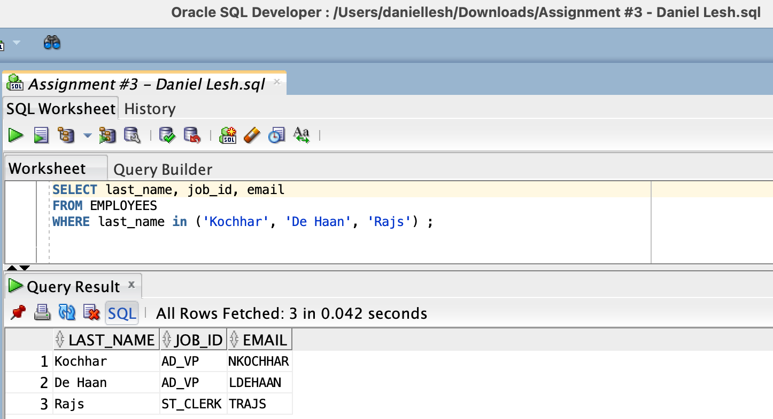
2. Display the first name, Commission percentage, and salary of all employees who earn a commission. Label

the columns First Name, Commission percentage, and Monthly Salary, respectively.

* + 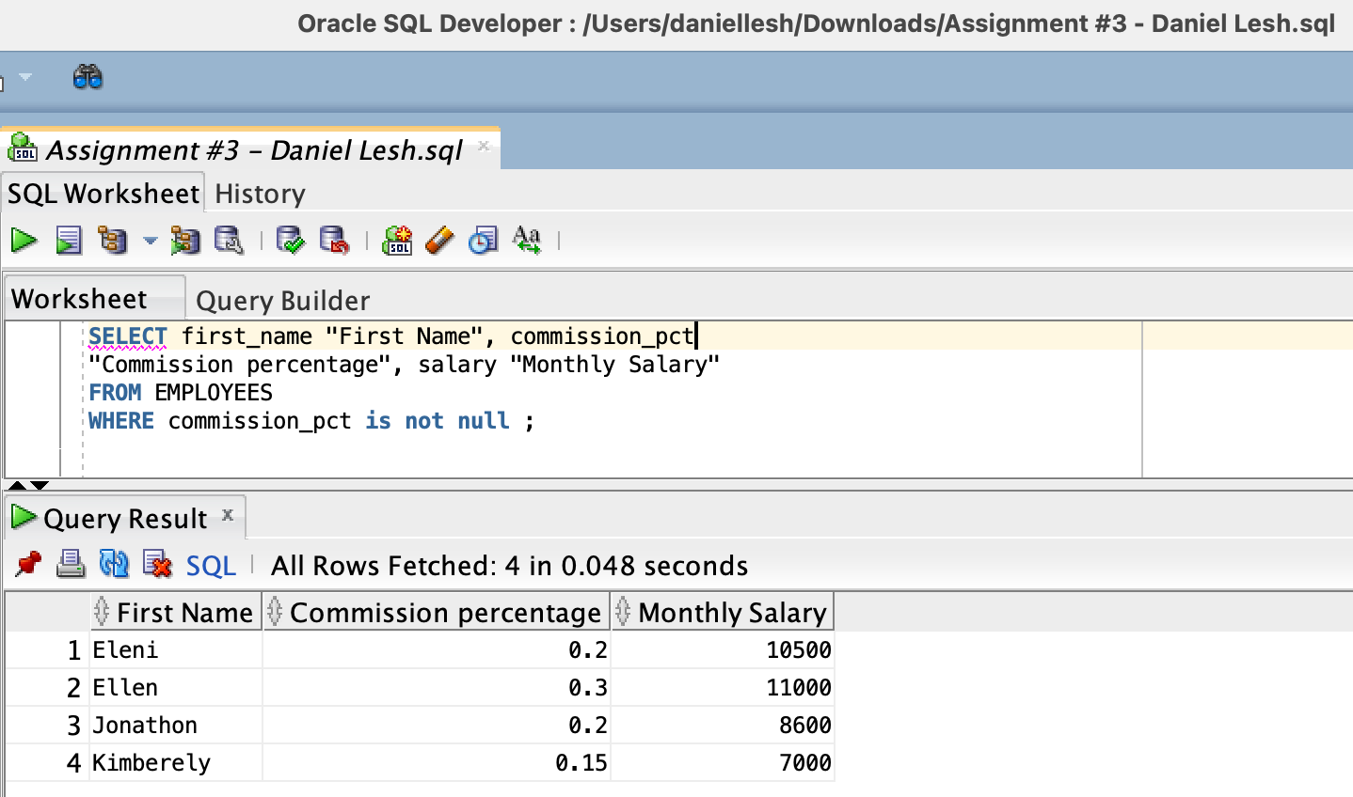

1. The HR department needs a report that displays the first name, last name, and phone number of all employees who were hired in 1998. Label the columns F Name, L Name, and Phone #, respectively.
   * 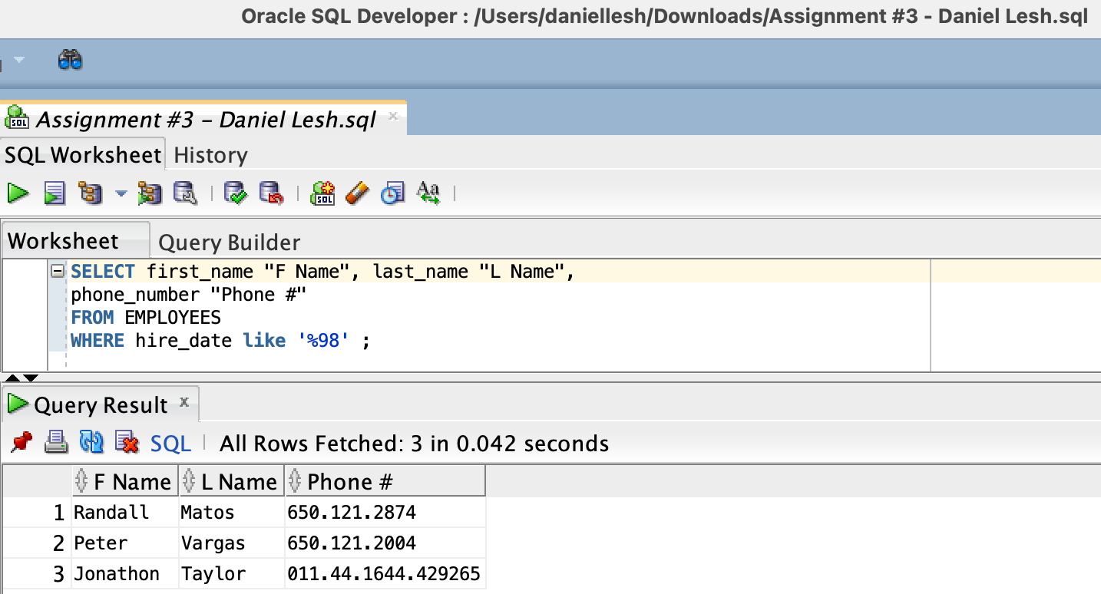
2. Create a report to display the last name, department id and salary where job title is SA_REP
   * 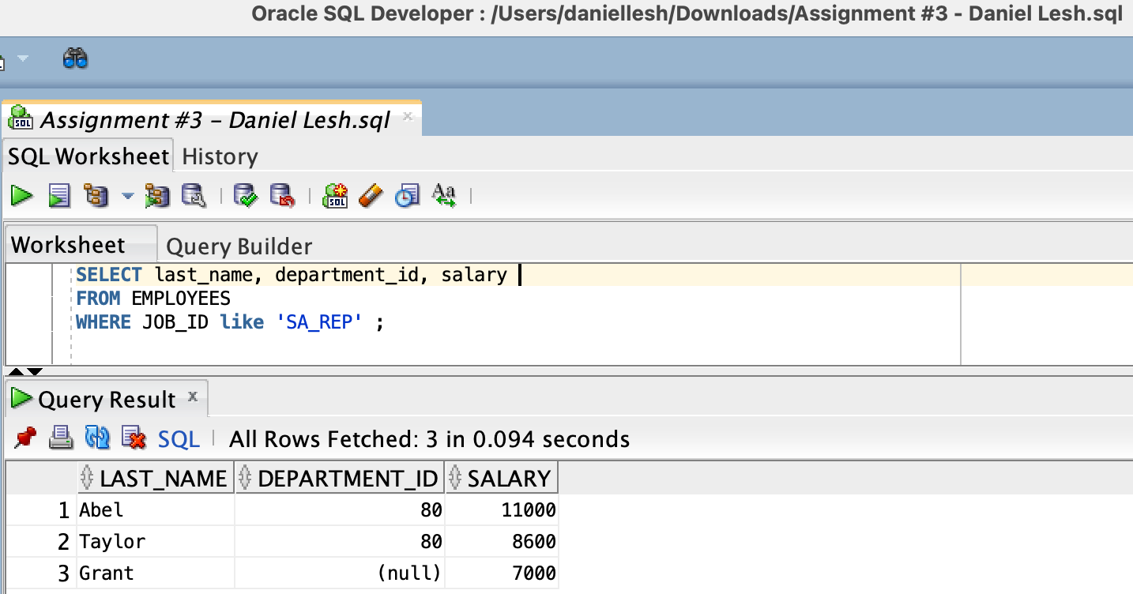
3. Create a report to display the last name, salary, and department id of all employees who have a 10 digit

phone number. Sort the data in descending order first by salary and then department id. Use the column’s numeric position in the ORDER BY clause.

* + **Set LENGTH equal to ‘12’ because when examining the Data from EMPLOYEES table, must include the ‘.’ separating the phone # characters.**

**🡪 Example: ###.###.#### = 12 total characters for a 10-digit phone #**

* + 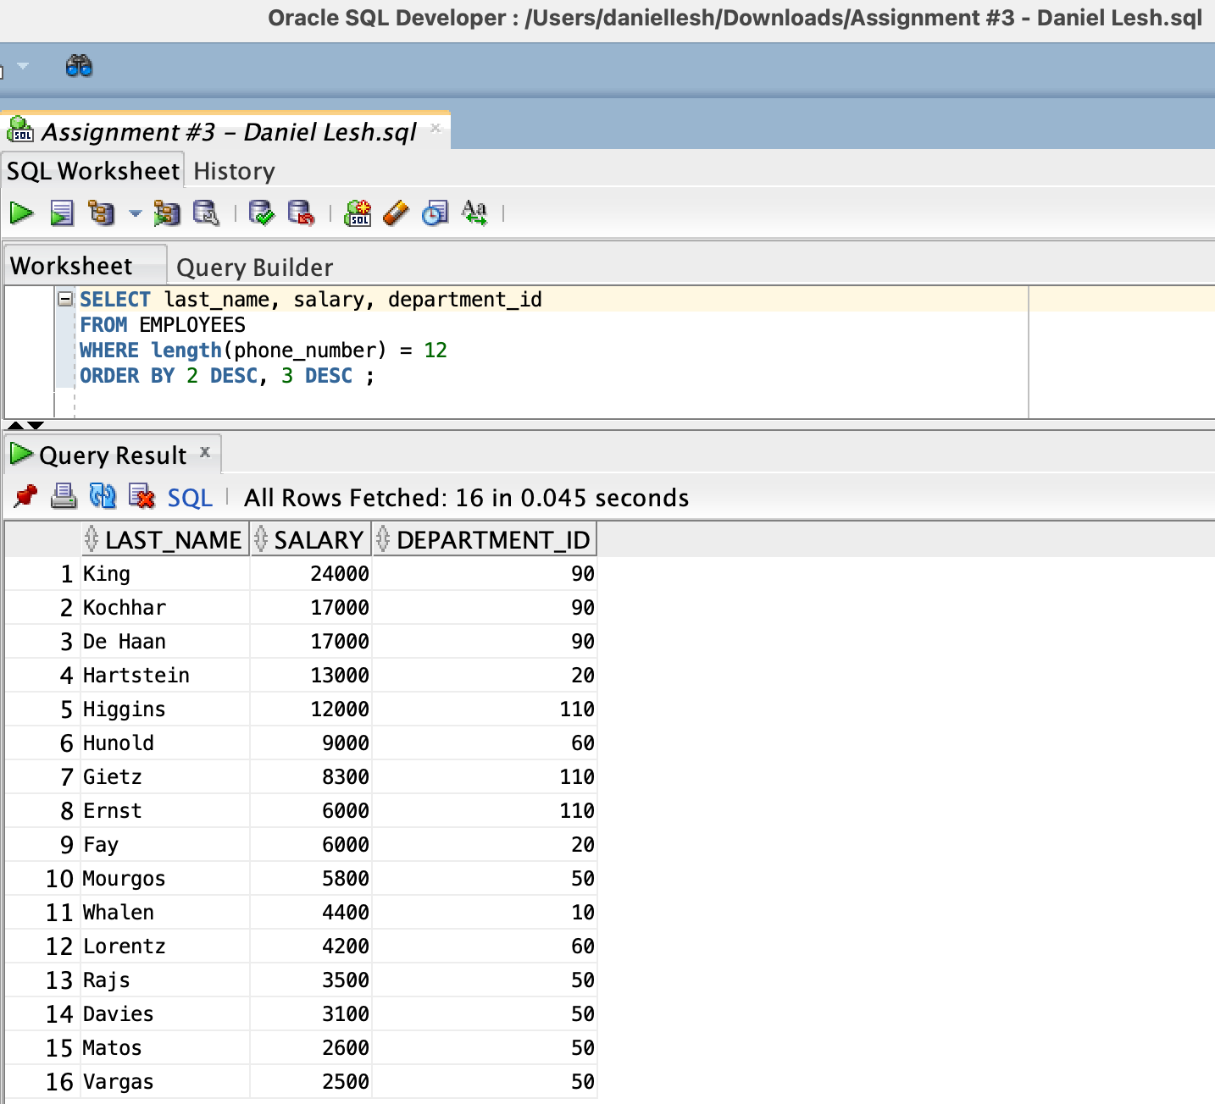

1. Members of the HR department want to have more flexibility with the queries that you are writing. They

would like a report that displays the last name, department id and salary of employees who earn less than an amount that the user specifies after a prompt. ENTER 10000 when prompted for a value in the dialog box. Screenshot the prompt box and the output (view) using that amount.

* + 
   